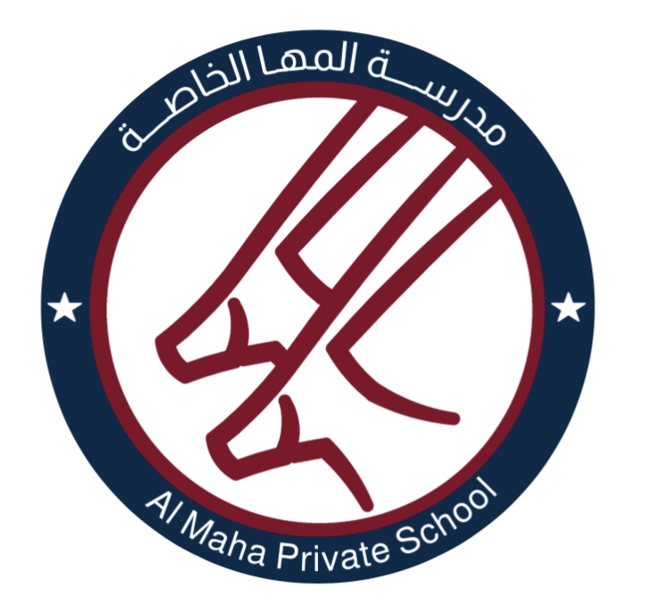
Al Maha Private School

Terms and Conditions for Academic Year 2020 – 2021
School Fees: Regulations
- All fees must be paid in full before the start of the first term in the new academic year.
- School Tuition Fees for 2020 – 2021
Class | Annual Tuition Fee | Two instalments plan: September 9th January 1st 2021 | Termly instalment plan: September 9th, January 1st 2021, April 1st | 6 instalments plan Sept 9th – Feb 1st 2021
KG1 | 2200 OMR | 1100 OMR | 733 OMR | 367 OMR
KG2 | 2400 OMR | 1200 OMR | 800 OMR | 400 OMR
Year 1 | 2600 OMR | 1300 OMR | 867 OMR | 434 OMR
Year 2 | 2600 OMR | 1300 OMR | 867 OMR | 434 OMR
Year 3 | 2800 OMR | 1400 OMR | 933 OMR | 467 OMR
- The Annual Fee must be paid before September 9th prior to the commencement of the academic year. Four payment plans are available:
- Full annual payment by cash, cheque, electronic transfer via debit/credit card* before September 9th prior to the commencement of the academic year will qualify for a 5% discount.
- A sibling discount of 5% from the annual tuition fee is applicable for the youngest child.
- Two payments by depositing two post-dated cheques before September 9th prior to the commencement of the academic year, in line with the instalment payment figure published above. All cheques must be dated as indicated above.
- Termly instalment plan by depositing three post-dated cheques before September 9th prior to the commencement of the academic year, in line with the instalment payment figure published above. All cheques must be dated as indicated above.
- Six monthly instalment payments by depositing six post-dated cheques before September 9th prior to the commencement of the academic year, in line with the instalment payment figure published above. All cheques must be dated as follows: September 9th, October 1st, November 1st, December 1st, January 1st, February 1st.
- Late payment of tuition fees will accrue an additional charge of OMR 15 per week.
- Refused cheques will accrue an additional charge of OMR 20.
- The School reserves the right to refuse to continue to provide education to children whose parents are in arrears and will withhold references / certificates / reports in such a situation. Please note that all monthly payment cheques will be presented to the Bank on the first working day in line with the date of the cheque.
- In the event that a child leaves the school during a term, no refund of any paid or owing fees will be made. Any outstanding fees must be paid before leaving the school.
- Signing the acceptance of the Terms and Conditions renders the signatory legally liable for payment of the whole of the fees which are due, eg. annual tuition fees, any additional charges. Even if a company is paying the fees, that payment is still the ultimate responsibility of the parent / guardian. Registrations will not be deemed complete until both the Registration Form and the Terms and Conditions 2020-2021 are completed, signed and returned to AMPS.

- Fees will not be reduced as a result of absence for any reason. Neither will fees be refunded or reduced for pupils leaving before the end of a term.

* Any additional bank charges for the use of Debit / Credit cards will be charged to the card holder.

Additional Fees
- Registration Fee: OMR 200. This is a non-refundable, non-transferable payment which secures a placement within the School. Except by prior agreement, if a place is not taken for one week after the start of the term, the School reserves the right to offer the place to another applicant.
For existing parents wishing to re-register their children for the following academic year, it is payable annually before the end of January 2021 at the rate of OMR 200.
For new children the fee is payable at the time of registration.
- School uniform: this is available through the school reception. Items are individually priced or available as a variety of packs. POA.

Acceptance of Terms and Conditions 2020 – 2021
I have read and accepted the terms and conditions of Al Maha Private School.
Registered child / children in AMPS ……………………………………………………………………………...
Parent ……………………………………………………………………………………………………………………….
Signature ………………………………………………………… Date ……………………………………………….

